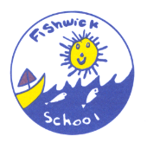Class: Mars

Term: Summer 2
This is our new homework grid, which is for this half term. You can complete any of the activities on the grid and then bring it into school to share with us; photograph, video, show or tell. The choice is yours. As always … if you are not sure, find an activity difficult or want to tell us anything … see your teacher so that we can help, or come along to our Homework Club after school on a Wednesday.
This half term our topic is Buckets and spades.

English  Read a story set at the seaside and write a book review about it.  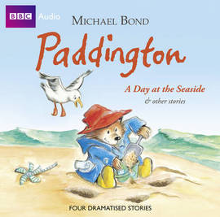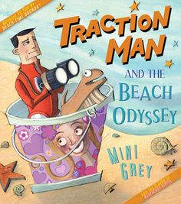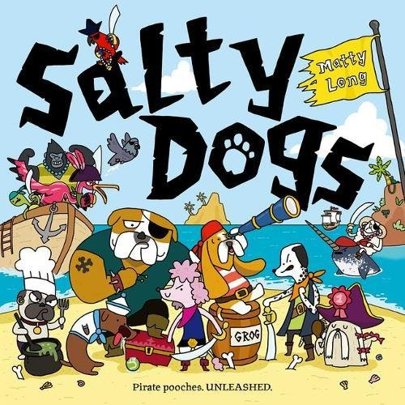 | English  Imagine you are at the seaside. What can you hear? See? Smell? Touch? Taste? Write a description of it.  Focus: Adjectives, Adverbs and use a range of punctuation ?,!. | Art  Paint a picture of a seascape. Focus: Mix different tints, Add texture e.g. thickness of paint, use of tools.  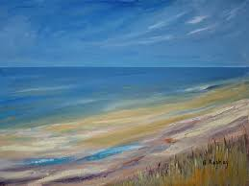
Art  Mermaids are mythical water creatures. Draw a picture of your own seaside mythical creature.  Focus: Name, Describe and Careful drawing. 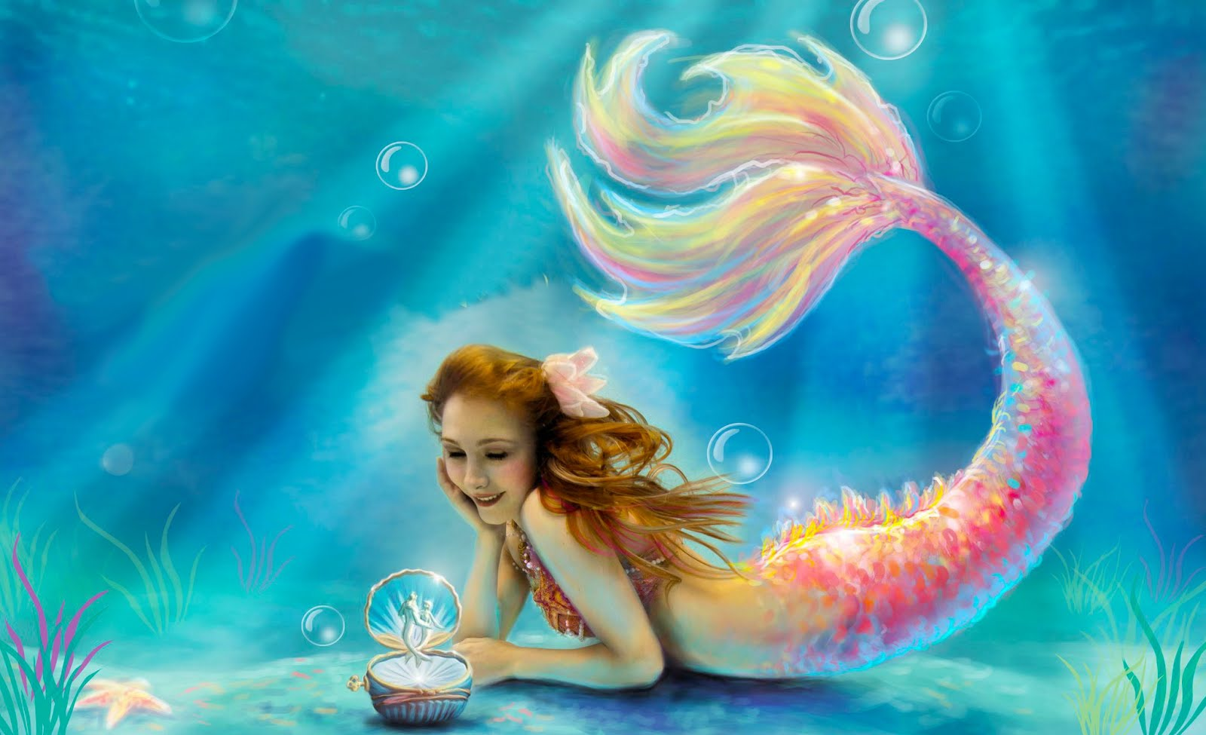 | D.T  Create a seaside in a shoe box.  Focus: Choose relevant seaside features, Design layout, Collect objects and evaluate. | D.T  Design and make a boat that can float with a light load. Focus: Design, Make, Choose a light load, Test and evaluate.  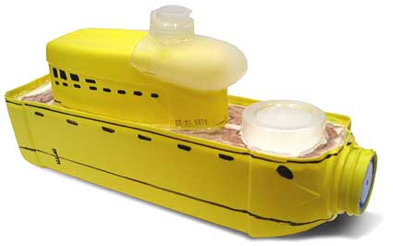
The tasks below should, if possible, be done every week as well as a task chosen from the list above.

Reading  Please share the book in your child’s reading folder and use the reading record to sign when they have done this.  Suggested timing: 10mins daily | English  Visit the homework section on Purple mash to complete the games set there.  Suggested timing: 10 mins | Mathematics  Practice your 2s, 3s (Year 2s) 5s and 10 times tables until you are super speedy and can say them in random order.  Suggested timing: 10 mins

