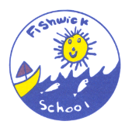
Fishwick Primary School
Downing Street, Preston, Lancs. PR1 4RH
Tel: 01772 491402
www.fishwick.lancsngfl.ac.uk
Headteacher: Mrs Vicki Conway
Dear Parents,

School App

We were pleased launch our brand-new app from Parentapps on Friday last week. I know many of you have already downloaded the app but if you haven’t please follow the instructions in the text message. We hope that the app will greatly improve the way we communicate with you will provide you with instant access to our calendar, event information, letters home and class pages. It also will link directly to our website

Christmas Updates

Our Christmas Mail Box will be open for business on Monday. The children can post cards to their friends for delivery but please make sure they put the name and class on the front of the envelope to help our festive helpers.

Christmas Raffle
Tickets for our annual Christmas raffle are on sale in the school office from 2nd December £1 a strip. The children can wear their own clothes on Friday 13th December in exchange for a donation of chocolate for raffle prizes.
Derian House
This year we are selling Christmas Flumps priced at £2 each & all the proceeds go to the Derian House charity.
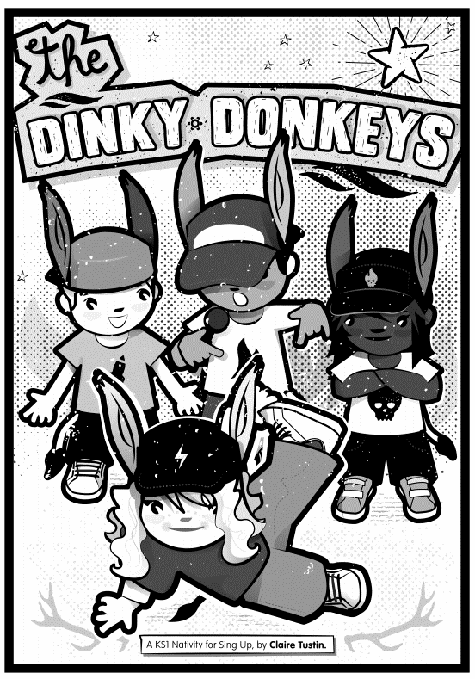
Christmas Performance
This year our Infant children will be performing a play called ‘Dinky Donkeys’. This will be followed by Christmas songs performed by the Junior Children. It should be a lovely way to get into the festive spirit. We will be sending out details of tickets soon although they will be limited due to fire regulations. There is no charge for tickets but Mrs McDonagh will have a collection bucket at the end. All donations to support our School Library.
10/12/19 -5.30pm Christmas Play
11/12/19 – 10am Christmas Play
Panto
16/12/19 – St Teresa’s will be joining us for Pendle Productions performance of the Pantomime Jack and the Beanstalk. “Oh no they aren’t…oh yes they are!”

Glitter & Glue
16/12/19 – 1.30pm Glitter & Glue followed by Christmas Raffle
All parents are welcome to join us in school for christmas crafts as part of our annual Glitter and Glue afternoon. To make it easier for parents we are going to have the children working in their teams so that all siblings will be together. This will be followed by our Christmas raffle at 2.45pm. We will also be presenting this half terms Shining Star Awards.

Please remember if your child attends the nursery in the morning you are very welcome to bring them in to join the Glitter and Glue fun, however we do ask that an adult stays with them.

Christmas Lunch
17/12/19 - 12pm Christmas Lunch
If your child does not have a free school meal you should have received a separate letter to enable you to book this.

Christmas Party
18/12/19 - Christmas party day
A traditional party with fun, games, food and maybe a special visitor. The children can wear their own clothes for party day. Please make sure that they have suitable coats and shoes in school for playtimes as it is still very cold.

Food Market
Our half termly food market will be held at 9am on 19th December. Please drop your child off and come round to the back entrance of school. You can fill a carrier bag with food for just £1.00, please bring your own bags as these will not be provided.
End of term

Don’t forget school closes for the Christmas Break at 13.15pm on Friday 20th December. We return to school on Monday 6th January 2020.

I am sure I will see you all in the upcoming weeks but if I don't for all of you celebrating, have a very Merry Christmas and a Happy New Year to you all.

Many thanks

Vicki Conway
Headteacher

