Home Learning Grid – Summer Term Week 4 |  |  | Saturn Class
Reading:  - Use read theory daily.  - Read a chapter a day of a book/magazine you haven’t read yet.  - Read and write the spellings for your year group. Practice daily. | Writing:  - https://www.literacyshed .com/takingflight.html watch this link and write an adventure story, include something exciting, extraordinary or a quest.  - Or write your own adventure story remember to use your imagination and include something exciting or interesting. | Maths:  - Use daily 10 on top marks https://www.topmarks.co.uk/maths-games/daily10  - Take turns to choose a two-digit number less than 50.  - Write it down. Now count up to it in fours. What number is left over? The number left is the number of points you score, e.g. Choose 27. Count: 4, 8, 12, 16, 20, 24. 3 left over to get to 27. So you score 3 points.  - The first person to get 12 or more points wins. Now try the same game counting in different multiples. Can you spot which numbers will score you more points?
D.T:  Design a new and exciting 2 player outdoor game.  You need to create rules and a set of instructions on how to play the game. Create an advert for your game that would persuade people to buy it. | Science:  Make a sun dial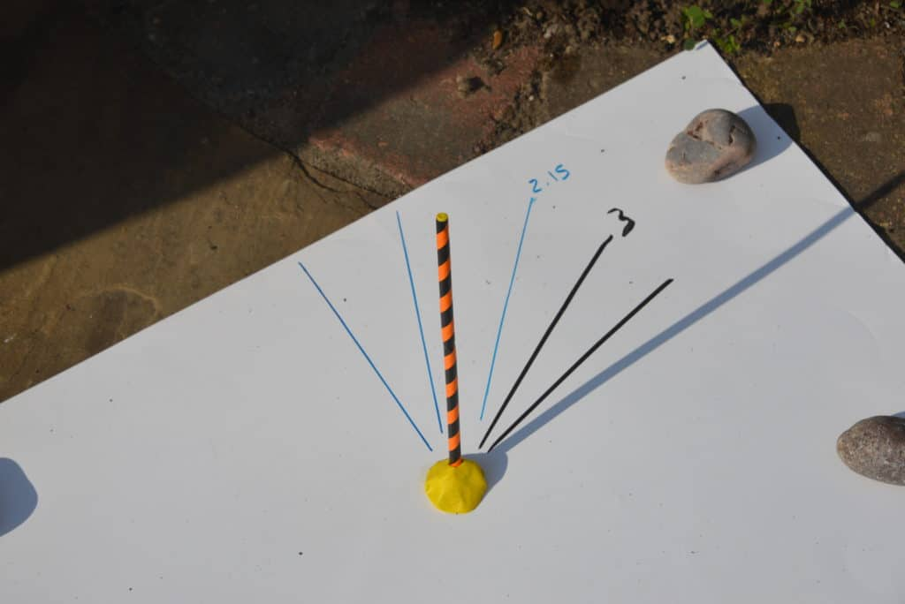  Use this link to help https://www.science-sparks.com/how-to-make-a-sundial/ | P.E:  - Go for a walk/run with a grown up every day.  - Create a fitness workout.  - Put your favourite song on and dance like no-one is watching!

