Fishwick Primary School
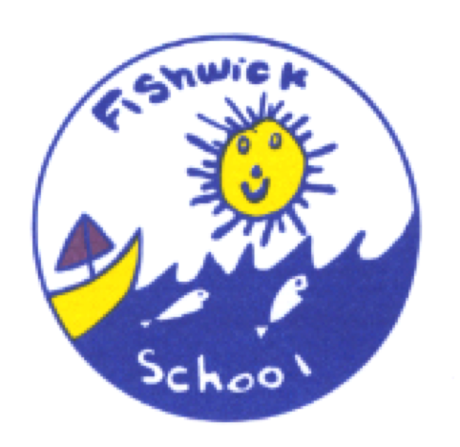
Sport Premium Report

This report outlines the spending and key achievements for the academic year 2019/20. Due to COVID-19 and enforced school closures this period only runs to 20th March 2019. Whilst there was clear qualitative data showing impact up to this point much of this work will continue into the next academic year.

Swimming Attainment

Percentage of your current Year 6 cohort who can;
swim competently, confidently and proficiently over a distance of at least 25 metres | 71%
use a range of strokes effectively [for example, front crawl, backstroke and breaststroke] | 71%
perform safe self-rescue in different water-based situations | 71%
N.B. Current Y6 cohort % are based on 15 pupils
2 pupils are not included as they arrived mid year and we were unable to assess them due to COVID-19

Fishwick use our Primary PE and Sport Premium to provide additional provision for swimming all children swim for 1 term each year during KS2. Two additional terms are funded in Year 6 for children not meeting NC requirements.
 | Key achievements | Funding allocated
Indicator 1:  The engagement of all pupils in regular physical activity. | - All children throughout school are involved in ‘the daily mile’ completed after lunch around the school pitch  - A wide variety of A.S.C are available throughout the year, which have included football, cheerleading and fencing most of these have been targeted to involve children who are less active than their peers.  - A small lunch club has been running to ensure less able children/poor motor skills are able to access P.E equipment and activities. The Anomoly interactive board is also available for this group to use.  - All classes timetabled 2X P.E weekly (excluding EYFS). | Playground games course half day (TA’s)  £2,160 Fitsense  Anomoly interactive board outside £6,335
Indicator 2:  The profile of PE, school sport and physical activity is raised across the school as a tool for whole-school improvement. | - SHINE therapy- daily physical circuits to improve behaviour and concentration. These children need additional physical exercise to release energy.  - Standing desks provided for each classroom to enable children to stand and work at their desks. | £2,805  £1,620
Indicator 3:  Increased confidence, knowledge and skills of all staff in teaching PE and sport. | - Lunchtime coaches teaching rules and regulations in various games, football, rounders, basketball etc. Children are to use skills taught in P.E in these sport clubs.  - New Lancashire PE app to be started for whole school PE from September 2020 to increase confidence and knowledge of staff.  - Training of interactive board outside.
Indicator 4:  Broader experience of a range of sports and activities offered to all pupils. | - New football/sport kit  - CtK competitive activities  - Clip n climb class trip  - Boys and girls football competitions entered  - UCLAN sports event | £628.40  £2,750  £178.50
Indicator 5:  Increased participation in competitive sport. | - CtK competitive activities  - DB sports competition girls and boys football teams  - Tennis coaching-CPD teacher. | £25

Sports Partnerships

Projected Actions 2021 – 2022

